THE TRANSFORMATION SALON

SALON APPOINTMENT BOOKING SYSTEM

E-COMMERCE TEAM PROJECT FINAL REPORT

20th November 2022

Team Members:

Nzube Anioke

Benjamin Nkansah

Shirley Yankyera

Tawina Chaposa

INTRODUCTION

The Transformation Salon is an e-commerce platform that provides an opportunity for customers to view a catalogue of available services, descriptions and respective prices, book their appointments and pay for the services before coming into the salon. Given the time-consuming nature of beauty and hair services, this project holds a significant amount of importance by reducing wait times and streamlining the process for both the service providers and the customers. When customers are able to choose a time slot, choose the services they want and pay beforehand, the expectations are set for both the customers and the stylists, as both parties are aware of the service to be delivered.

Our company is committed to its immediate environment which we account for through our corporate social responsibility. Our website provides an option for customers and well-wishers to donate, which will be used to provide training for socio-economically disadvantaged communities and increase financial security and the standard of living for the community.

BACKGROUND

The beauty industry in Ghana is a lucrative business area, majorly operating in the informal business sector. To start a small to medium salon business in Ghana, one needs to acquire the right training or hire individuals who possess the necessary training, secure a business location and equip the business with the necessary beauty equipment and products.

In the typical salon shop, customers either walk-in for their hair or call ahead of time to inquire about the hairdresser’s availability and reserve a spot for the services they need. The challenge with this method of booking lies in the fact that it is not strictly enforced and as such, a customer who is a few minutes late for their appointment might end up waiting for more than 3 hours to get their hair done, if the hairdresser starts working on another customer’s hair within the timeframe of the initial customer’s delay.

Other salons have tried to mitigate this problem by providing web applications for their customers. However, a majority of the salons implement only the front-end design without a comprehensive and responsive server-side implementation that allows the user to book and track appointments.

Our project seeks to leverage this problem space and provide the business and customers a well-rounded platform to start and complete the entire customer experience on the web application.

BUSINESS PLAN

Customer Value Proposition

Revenue Model

**Revenue Model**

To generate income, the following are our top revenue streams:

* **Hair dressing services**: we will be providing hairdressing services which include washing, hair cutting, hair braiding, hair dyeing/coloring, wig installations, among other customer choices. Each hair service will have its own price according to their unique differences like length of braids, hair style, the products the customer chooses to use while getting their hair done.
* **Pedicure/manicure:** we will offer curation and care of our customers hands and feet with nail care and artificial nails enhancements that will be customized according to the customers' preferences. The preferences will determine the amount we charge, for instance, long nails will have a slightly higher price than short nails, etc.
* **Donations:** We consider donations as one of the income sources but not a strong revenue stream. We believe that people will be kind enough to understand the purpose of donations and take action to donate to help others.

MarketSpace of Business Operation

**etspace of operation/ main competitors**

Businesses that primarily offer hair care services to both sexes make up the salon sector, a subset of Ghana's beauty care industry. As a result of rising demand, auxiliary services, including skin care, massages, hair straightening, perms, and hair colours, have been added to the conventional hairdressing and barbering services that have long dominated this sector of the economy. Despite focusing primarily on hair services, some have even gone so far as to provide spa treatments, pedicures and manicures, nail care, and other beauty services. The development of expansive and upscale salons like Exotic Trends, First Choice Hair & Beauty Salon, and Studio 7 Beauty Lounge is significant because of new and emerging trends and technological breakthroughs in this business. The aforementioned are important market participants we found when researching our industry niche and who take up a sizable portion of it. They have a vast customer base and a significant market share as a result of the efficacy of their services. The salons mentioned above are typical examples of experts in hair care and styling while also expanding their services to other beauty-related fields. Despite this, additional hair salons are opening up and attempting to gain a competitive edge by specialising in a particular aspect of hair care, particularly for natural hair. Some of these specialised salons that serve clients with naturally curly hair and those who enjoy varied hair locks are Eya Naturals Salon and Spa, Ntouch Naturals, and Twists and Locs Salon.

Main Competitors

Comparative Advantages

By providing a complete experience for our customers from the time they visit our home page to payment, we are a step above other market players who do not have a comprehensive server-side application. We are also located in a prime business area with fewer salons and competitors.

Market Strategy

We aim at using a focused differentiation strategy which looks at providing high quality and premium service to our target market. Our target market are students in Ashesi University and individuals around the Berekuso community. We provide numerous but different services to create value and a good experience for our customers.

Organizational Structure

Our organization uses a hierarchical structure with a salon manager at the top of the chart.

Management Team

HIGH-LEVEL IMPLEMENTATION

Architecture: The Model View Controller (MVC) architecture was used in the implementation of this project. The MVC architecture is a model that divides application into related elements to separate the representation of the software’s logic and user display. This ensures division of labor, improves maintenance and allows for easy updates and debugging.

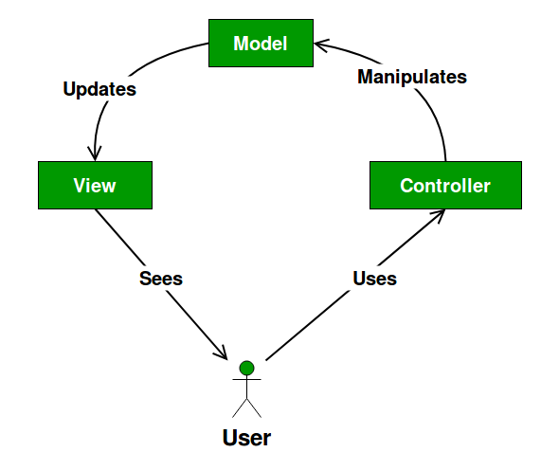

**The Model: The model contains the components of the application that implements the logic**

**Client-Server architecture**

**Presentation- for frontend purposes(html), to display our services to the customers**

Languages – html, CSS, JavaScript

**Database- for data storage (customer data, products data)**

Languages - MySQL

**Application- server side (processes user requests from the front end)**

Languages **–** php

**MVC**

Tools

Libraries -

Flowchart

Requirements

|  |  |  |  |
| --- | --- | --- | --- |
| **Business Objective** | **System Functionality** | **Information Requirements** | **Assigned to** |
| Display a list of different hair products and services   * Our services are barbering, manicure and pedicure, wig constructions * Our products include hair oil, conditioner, shampoo, beard oil, hair spray | Product and service catalog | Details of product and service catalog (product availability, photo, purpose, price) | Benjamin  Tawina |
| Provide booking option for customers to make appointments beforehand | **Responsive c**alendar showing available times for staff. | Available times, names of staff and service for each slot, withdraw appointment | Shirley |
| Constant communication and quick resolution of customers' concerns | Live chat |  | Nzube |
| Provide product/service information | Product and service database | Product ID, name, price, image, description, reviews | Tawina |
| Execute a transaction | Payment / donation platform | Name, payment channel, ID, amount, Donate action button | Shirley |
| Accumulate customer information | Customer database management system | Name, address, email, telephone, online customer registration | Nzube |
| **Upload and update information on products** | **Inventory management** |  | **Benjamin** |
|  |  |  |  |
|  |  |  |  |
|  |  |  |  |

Frameworks – Bootstrap

APIs- paystack